**Remote Access**

**First step to configure remote access in Ubuntu**

**First Step:- sudo apt update**

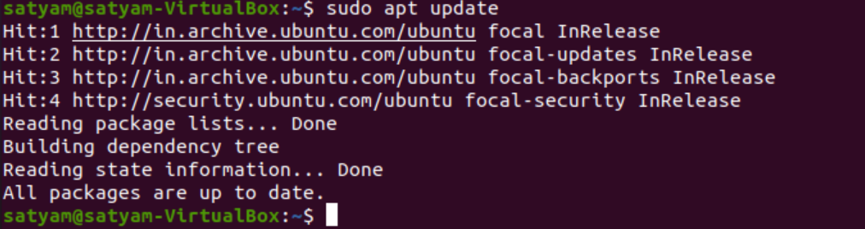

**Second step :- *sudo apt install xrdp***

**xrdp is a package which is responsible for the remotr desktop setup in our machine.**

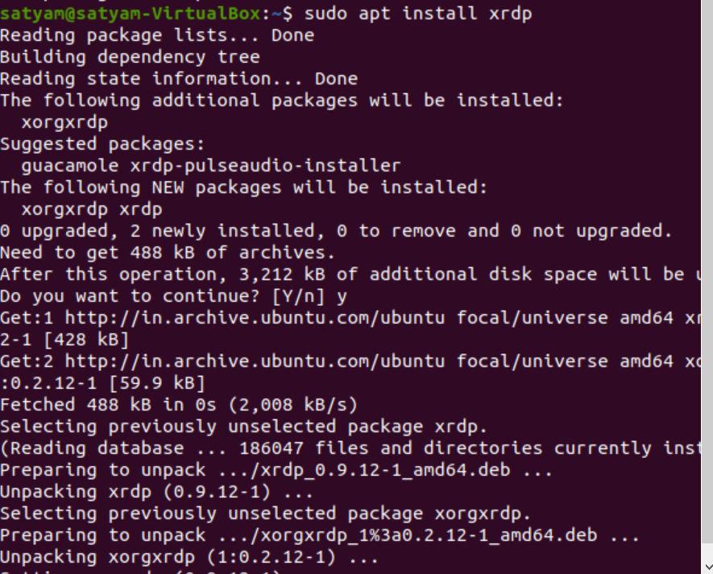

**Step 3 = sudo systemctl enable –now xrdp**

**Now we use this command to enable and start the xrdp service**

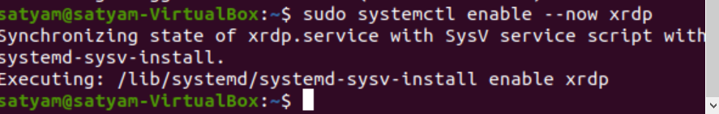

**Step 4 = sudo ufw allow from any to any port 3389 proto tcp**

**Here we define a port number.**

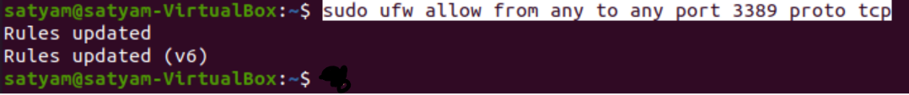

**Step 5 = ip a**

* **we check our machine ip address of our machine, the ip adresss of our machine is 192.168.0.6**
* **With this ip address we will try to do remote desktop(rdp) in our machine in step 6**

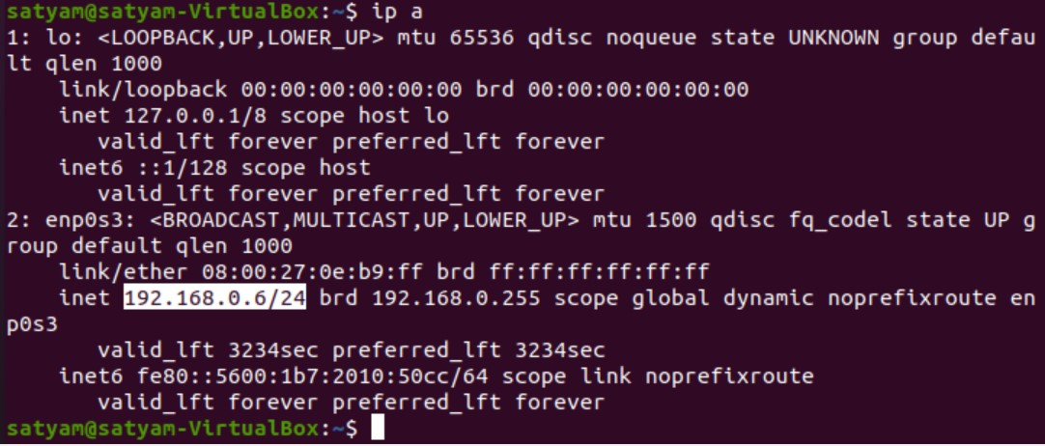

**Step 6 =**

**Setup remote desptop machine (rdp)**

* **Firstly we search remote desktop connection in our system search bae and open it**
* **Enter ip address and connect before continue you logout your machine in virtulbox software because a machine login one time in one system ,after connect you give a username and password & you see your machine will start**
* **Remember only logout your machine in virtualbox software not shut down**

